Ondernemingen Jan De Nul N.V.  Ondernemingen Jan De Nul N.V. |  |  |  | Installation guide for field engineers
 | AmosW server installation. |  |  | Module:
 |  |  |  | Reference: |  | Version: | 08
 |  |  |  | Author: | De Troyer Frédérique | Date: | 14/12/2015
AmosW - Server installation.
Subject: |  | AmosW server installation.
Location: |  | MESO
Date: |  | 23/02/2017

Goal
AmosW – Server installation.

Guide

- Check the date and time on the server.

- Set the formats to “English (United Kingdom)” in the “Region and Language” tab (control panel).

- On the administrative tab click “Copy settings”. Select “Welcome screen and system accounts” and “New user accounts”, now click “OK”.

- Go to \\dmm-file03\altsoftlib$ and copy the necessary folders and files on a portable medium. >> You can also push the software with Symentac. Make sure not to reboot or shutdown the machine while AMOS is installing.
  - Software to install:
    - AMOS server
    - amos xt client
    - amos replication << Manual install
    - comme server remote

  - Add the JDN-number and replication number \\dmm-file03\altsoftlib$\_ImportData >> JDNNumbers.txt

- Install the Amos and amosXT prerequisites with the same sequence as the deployment console. The standard values could be used for all fields.

- Create a new “Environment variable” << Only when It isn’t picked up by step 4b
Variable name: _NS_JDNNUMBER
Variable Value: installation number (4 digits).

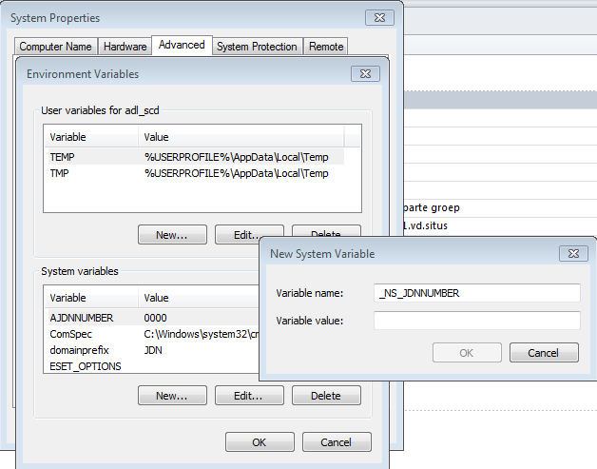

- Install amos server, amos reports and amosXT . Once again, make sure that the machine is not rebooted or shut down during the installation.

- Copy the amos database (amos.db and amos.log) on the XX-APPS01 server to D:\databases\sybase\amosxxx or E:\databases\sybase\amosxxx . For a new installation you can obtain the database from “SSE amos support”. In case of an existing installation you can copy the DB from the old server. Stop and disable the amos service in Sybase central and copy the files to the new server.

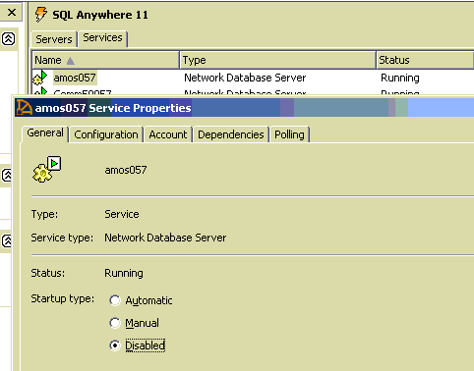

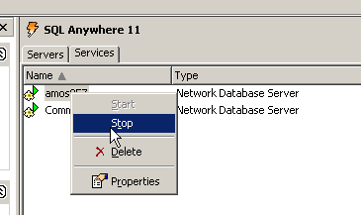

- On a windows7 amos server pc:
a. Remove the “Create Amos Drive” from the startup-folder.
b. Remove the K-drive with the MS-DOS subst command (Subst k: /D ).
c. Share “D:\ApplicationData\Amosw” with everyone (RW).
d. Map the K-drive to \\localhost\amosw (reconnect at logon).
- Install amos replication. (\\dmm-file03\altsoftlib$\AMOS Replication 6.4.29)

- Copy the necessary graphics from \\jdn-file01\amosd\AmosW\GRAPHICS to K:\AmosW\GRAPHICS.

Graphics to be copied:
      - All files in the root of the directory
      - The directory of the ship or workshop. In case there is no ship or workshop directory, you can skip this
      - The “jobs”-folder
      - The “history”-folder from old server. << Only when it’s a migration
      - The “00-AMOS-ATTACHMENTS-FLEET-GENERAL”-folder

Copy \\jdn-file01\Amosd\AmosW -> PBL files from the REPORTS-OLD folder to \\XX-APPS01\AmosW\REPORTS

- Copy the “amos software”-folder from \\jdn-file01\amosd\AMOS\AMOS SOFTWARE to the K-drive of the ship or workshop. Keep the same directory structure.

- Amos RT: Copy the content of the “Local Installer” folder for the latest Amos Remote Task version in \\jdn-file01\software$\Software - JDN DotNet Development\Logistics\AMOS\Amos Remote Tasks to D:\ or E:\applicationdata\AmosRT. Create this AmosRT directory, in case he doesn’t exist.

- Initialize CommE >> C:\Program Files (x86)\JDN\CommE\Jdn.CommE.Updater
>> Browse to the XML file provided by Frederique De Troyer
(This is only when the migration is happening!)

